TERRANEXT GLOBAL VENTURES
AI Intelligence Platform
Technical Architecture Guide
Document 3 of 8 · Version 1.0
August 2, 2026
CONFIDENTIAL — Prepared exclusively for TerraNext Global Ventures

Document Control
Document Title | AI Intelligence Platform — Technical Architecture Guide
System | TerraNext Business OS
Classification | Confidential — Client Delivery
Prepared For | TerraNext Global Ventures
Prepared By | Engineering Documentation Team
Status | Final
Related Documents | Developer Guide; API & AI Workflow Guide; Known Limitations & Engineering Notes

Version History
Version | Date | Author | Description of Changes
1.0 | 2026-08-02 | Engineering Documentation Team | Initial release — converted from the Markdown source of truth for client handover.

Table of Contents
Right-click this table and choose "Update Field" → "Update entire table" to populate page numbers after opening this document in Word.

Every diagram and claim below is derived from the current implementation, not a design intent. Implementation gaps, trade-offs, and forward-looking notes are deliberately kept out of this document — they are consolidated in 04 — Known Limitations & Engineering Notes, referenced by ID (e.g. L1, P2, R1) wherever relevant below.

1. Module boundary and code layout
The module is a self-contained "feature" following the repo's standard feature-slice pattern (Doc 02), plus a small Cloud Functions package for the parts of the pipeline that must run server-side, unattended, and outside the request/response lifecycle of the web app.
src/features/ai-intelligence/
schema.ts — Zod schemas, constants, TypeScript read-model types
logic.ts — pure functions (chunk planning, storage paths, labels, formatting)
repository.ts — all Firestore reads/writes (Admin SDK)
queries.ts — read-only query façade used by Server Components (pages)
actions/ — 'use server' mutations (create, delete, record-audio, retry, settings)
components/ — client + server UI components
index.ts — the only import surface other code is meant to use

src/app/(app)/ai/ — 7 Next.js pages (thin: permission check + data fetch + render)

functions/src/ai/
process-session-job.ts — the one Cloud Function (Firestore trigger)
chunk-pipeline.ts — pure merge/selection logic, unit-tested independently
retry-with-backoff.ts — generic retry helper
providers/ — provider abstraction (types, factory, mock, gemini, openai, json)

Everything outside src/features/ai-intelligence/index.ts's exports is private to the module by convention (lint-enforced import boundaries per Doc 02). The Next.js app and the Cloud Functions package never call each other directly — they communicate exclusively by writing and watching Firestore documents.

2. System architecture
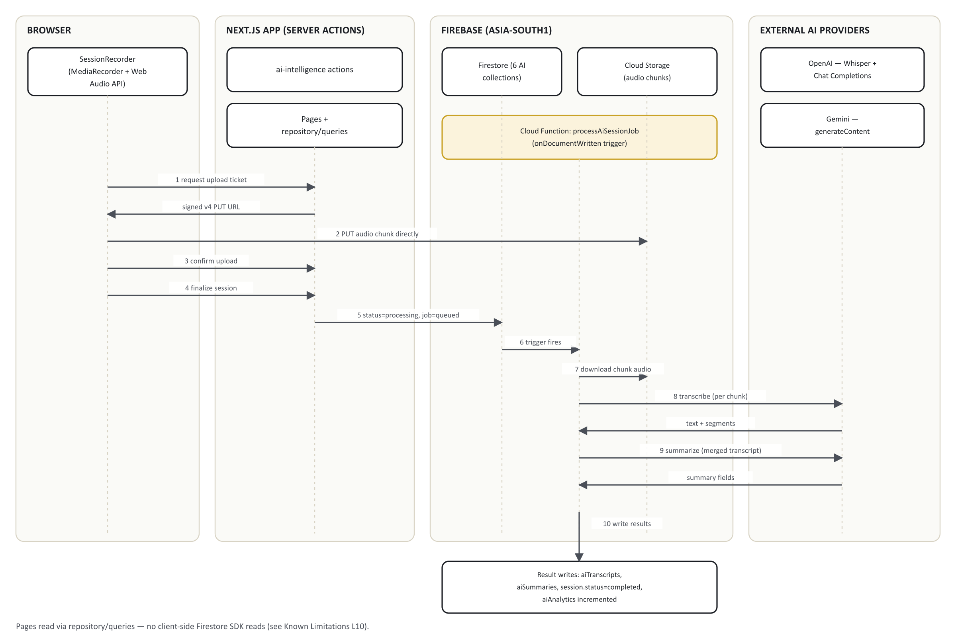
Figure 1. System architecture — component and data-flow overview.

Key architectural facts
- No client-side Firestore SDK reads. "Live" UI updates are implemented via a client component (AutoRefresh) calling router.refresh() on a setInterval, not onSnapshot realtime listeners (see L10).
- Every Firestore write to an AI collection is `allow write: if false`. All writes happen exclusively through the Admin SDK: Next.js Server Actions (adminDb()) or the Cloud Function. No browser can write directly to any AI collection, regardless of role.
- Audio never passes through the Next.js server. The browser uploads chunks directly to Cloud Storage via a short-lived (30-minute) v4 signed URL minted by a server action.
- The Next.js app and the Cloud Function never call each other's code. The only coupling is the aiProcessingJobs collection: the app creates a job document with stage: 'queued'; the function's Firestore trigger reacts to that write. Either side could be redeployed or rewritten independently as long as the job/session document contract is preserved.

3. Workflow diagram (end to end)
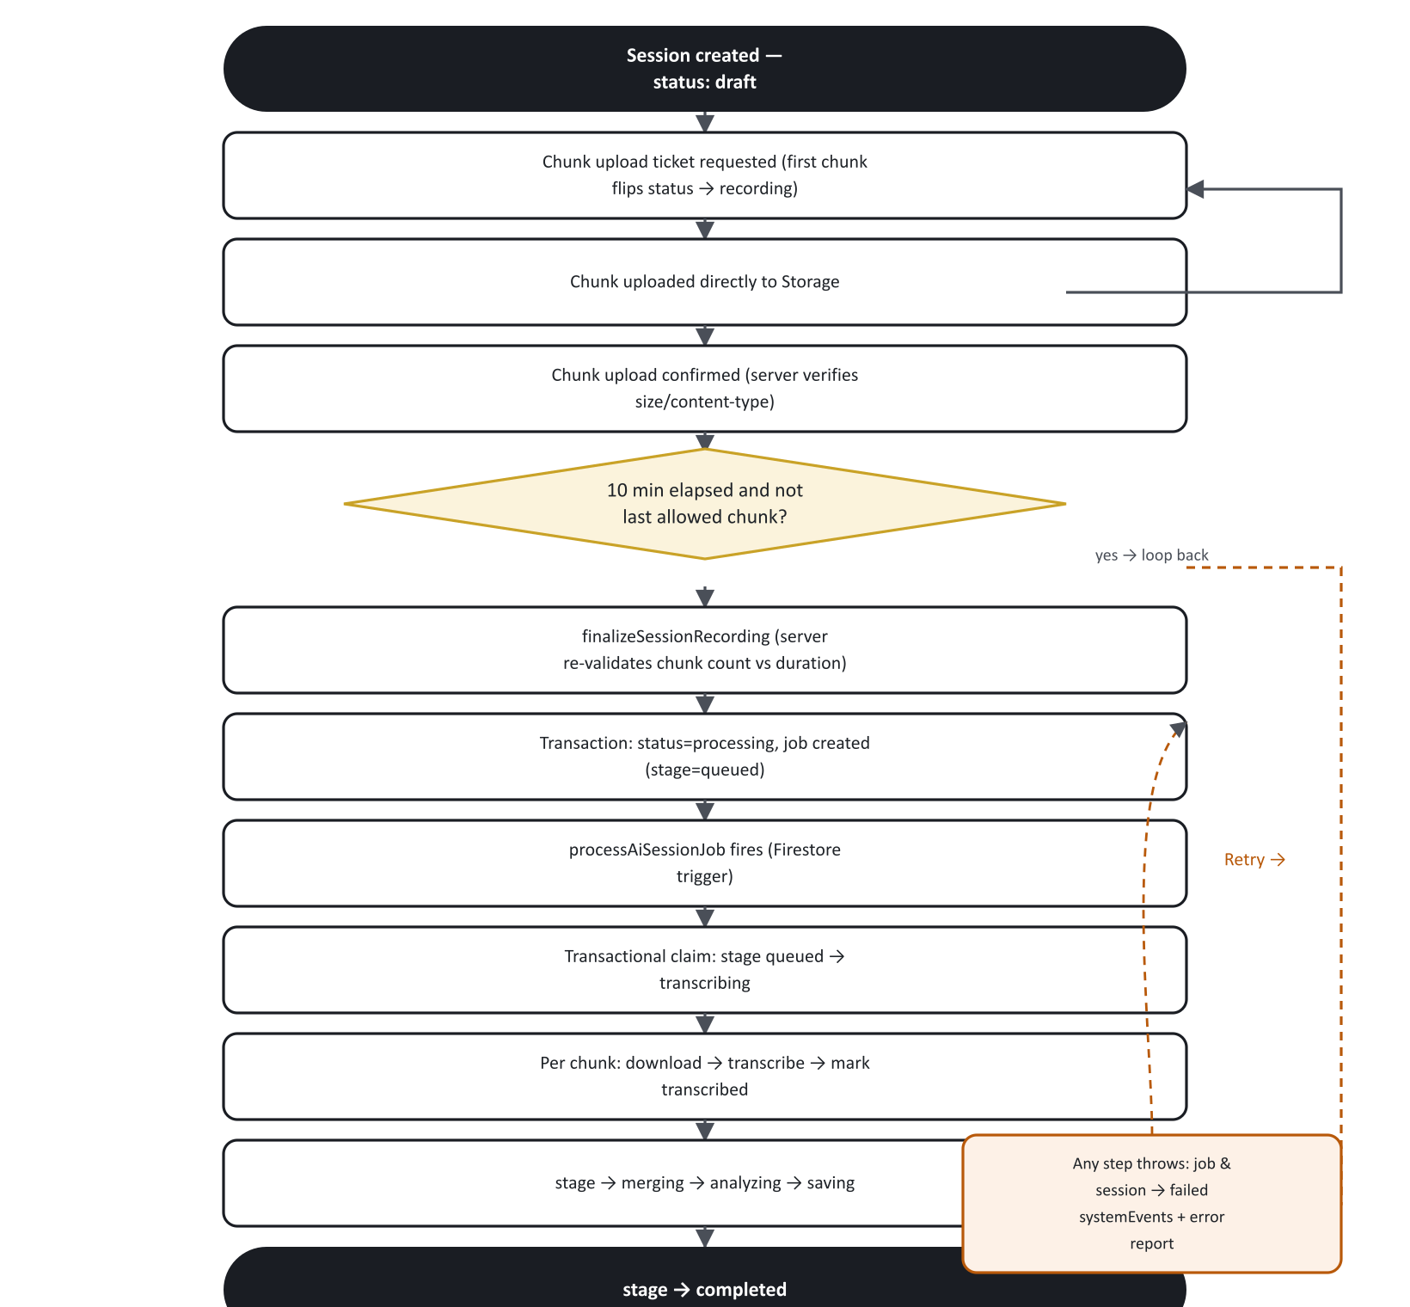
Figure 2. End-to-end recording and processing workflow.

4. Sequence diagram — one full session
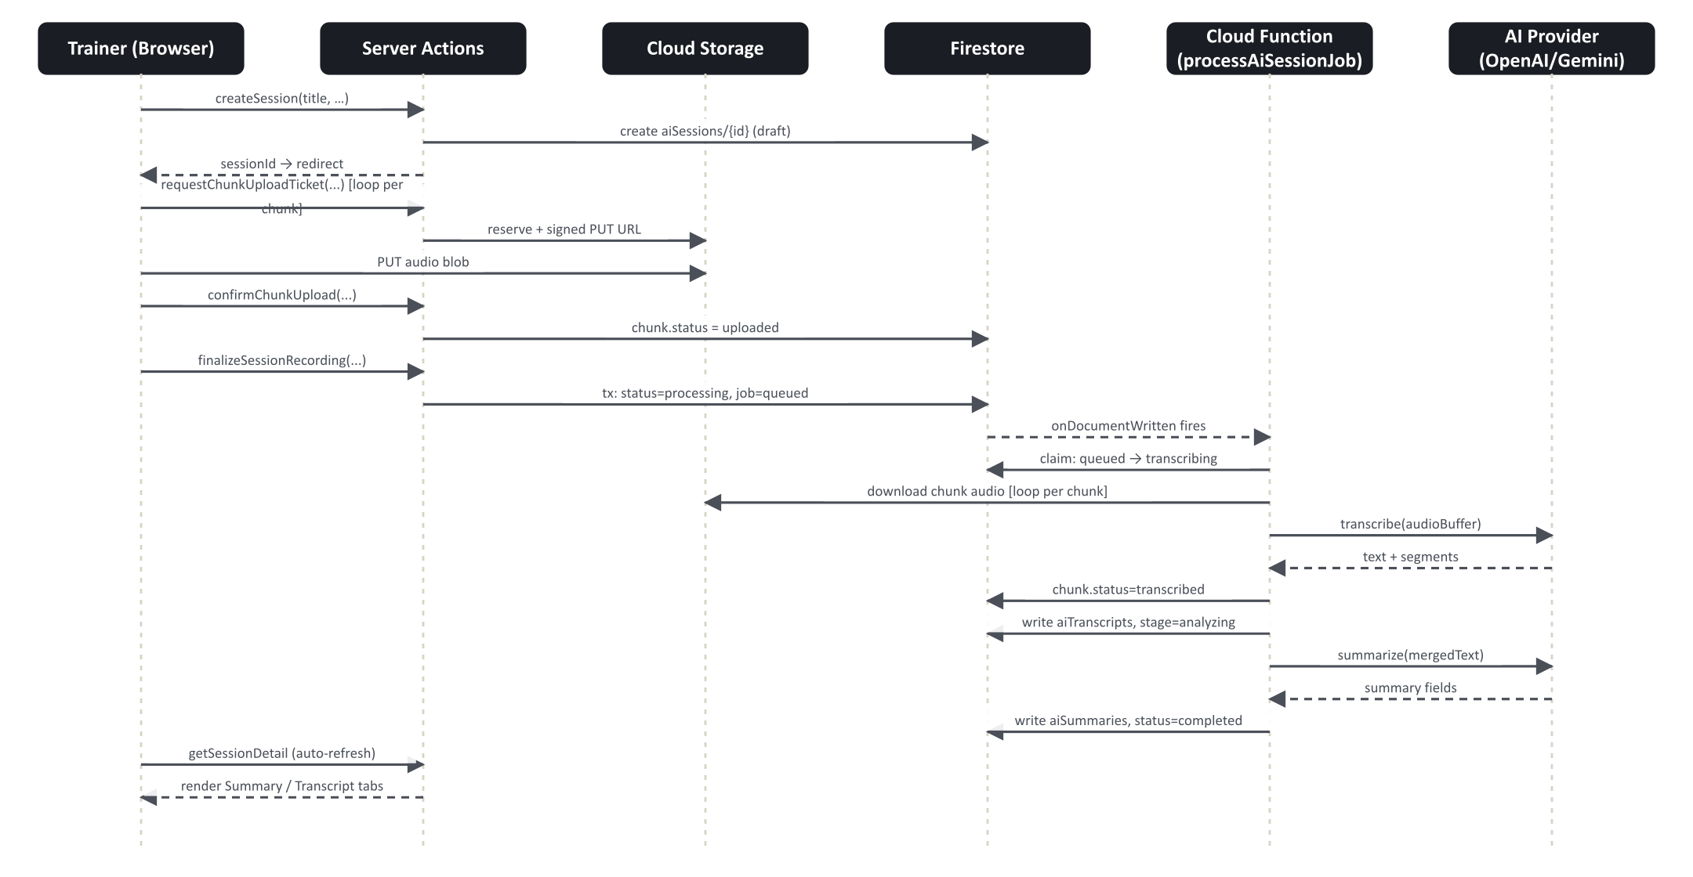
Figure 3. Sequence diagram — one full session, client through provider.
Chunks are transcribed strictly sequentially, not concurrently — see R1.

5. Processing pipeline (stage state machine)
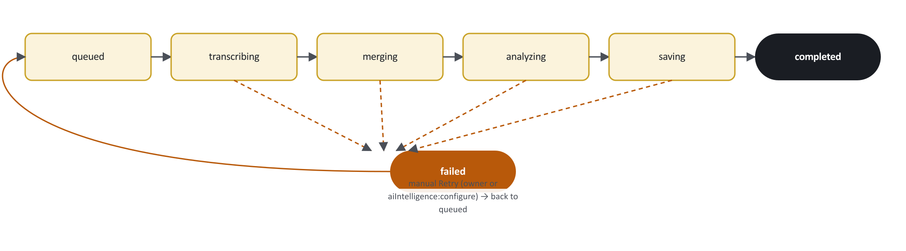
Figure 4. Processing pipeline stage state machine.
progressPercent shown in the UI is a fixed mapping, not a continuous measure: queued=0, transcribing=15, merging=60, analyzing=70, saving=90, completed=100, failed=0 (the failed state resets the bar rather than freezing it at its last value).

6. Database diagram
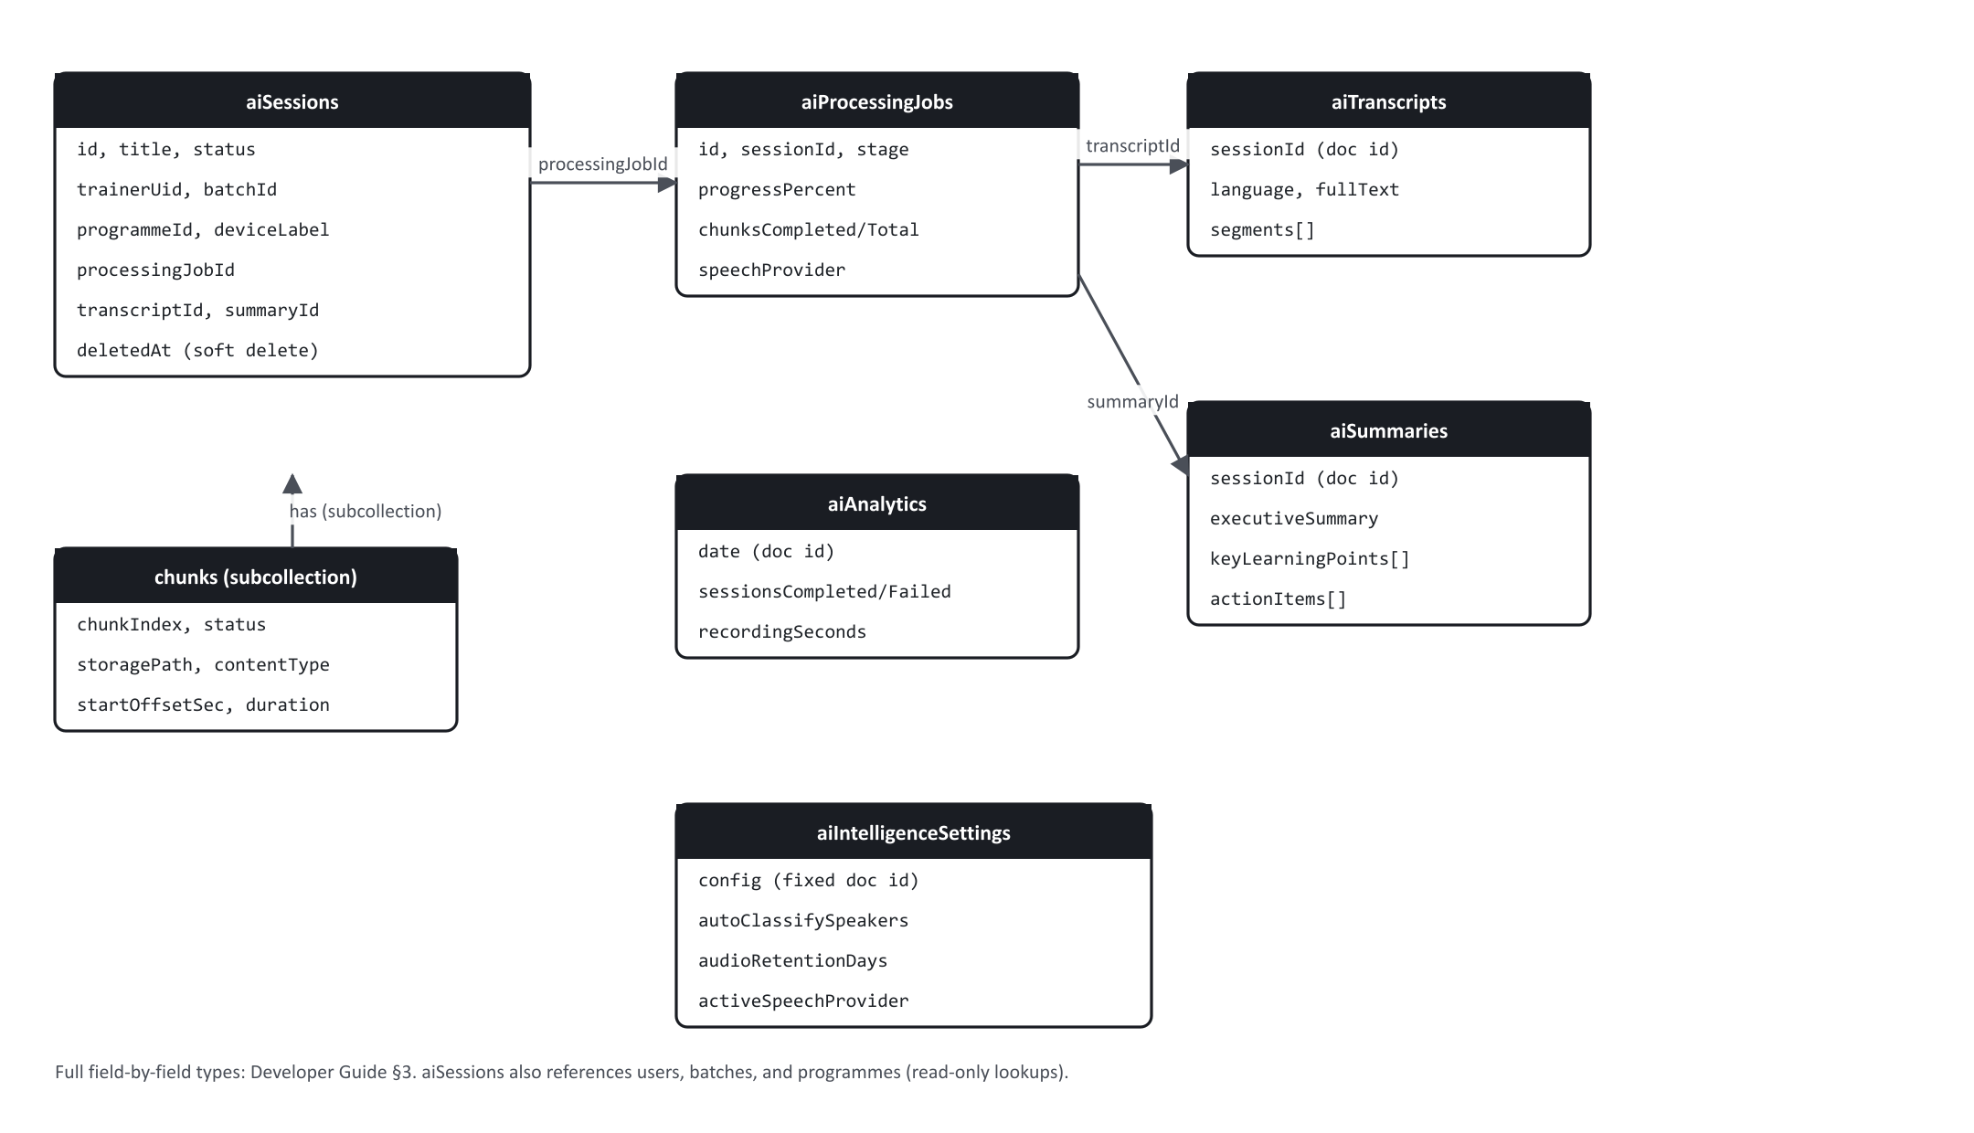
Figure 5. Database entity-relationship diagram.
Full field-by-field detail (exact types as coded) is in 02 — Developer Guide §3.

7. Cloud Function internal flow
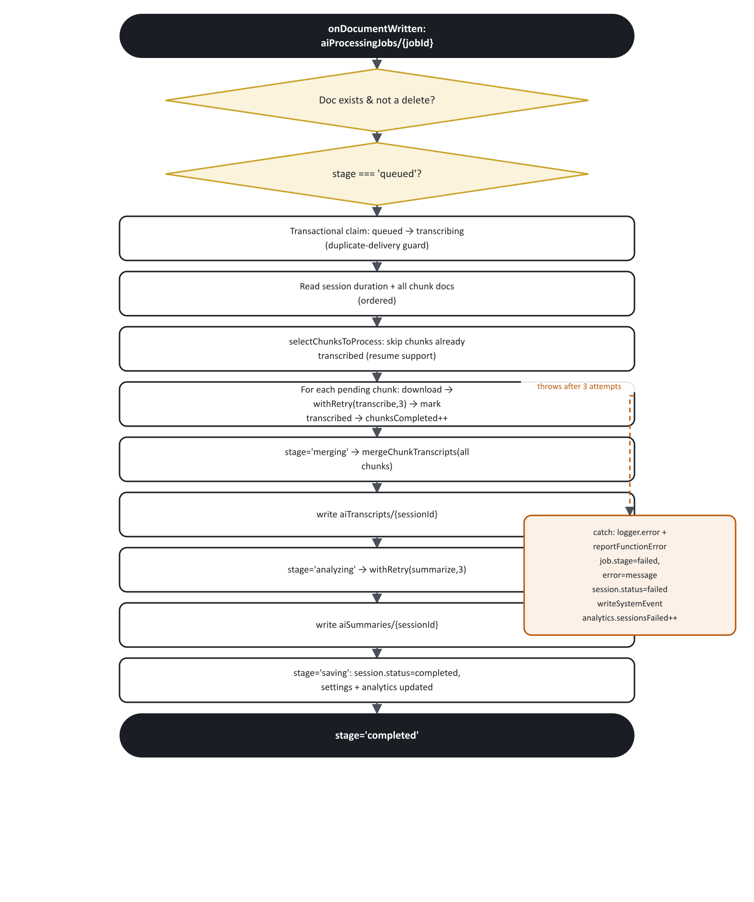
Figure 6. processAiSessionJob internal control flow.
Config on this function: secrets: [GEMINI_API_KEY, OPENAI_API_KEY], memory: '1GiB', timeoutSeconds: 540 (9 minutes), region asia-south1 (global default, maxInstances: 10). See R2, R3, R4 for the performance implications of this configuration.

8. Recording flow (client-side state machine)
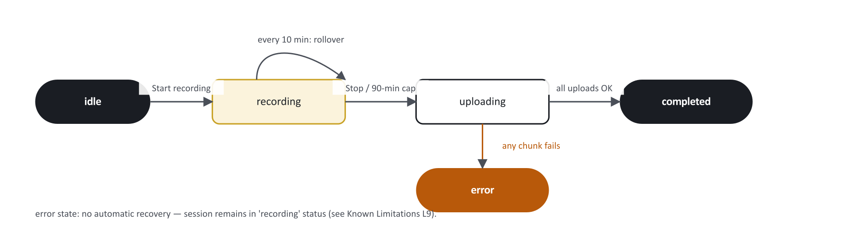
Figure 7. Client-side recording state machine.
The recorder does not use one continuous MediaRecorder instance for the whole session. It deliberately stops and restarts a new MediaRecorder on the same MediaStream at each 10-minute boundary, because concatenated ondataavailable blobs from one continuous recorder are not independently decodable audio files, while stop/restart produces genuinely independent, valid files per chunk — at the cost of a sub-100ms audio gap at each boundary. The last allowed chunk (index 8, the 9th chunk) receives no rollover timer of its own, only the whole-session 90-minute cap or a manual Stop — this avoids a rollover and the auto-stop firing in the same instant and producing a 10th, over-the-limit chunk. See L9 for what happens if the tab closes mid-recording.

9. Security architecture summary
Full detail in 02 — Developer Guide §5.
- Firestore: all 6 AI collections/subcollection are read-gated by role (generated can_aiIntelligence_view() and sibling predicates, sourced from the same ROLE_PERMISSIONS map that drives the app) and write-denied to every client unconditionally (allow write: if false). Authorization for who can do what is enforced entirely in the Server Actions, not in rules. See L1/L2 for the scope of what "role-gated" does and does not restrict today.
- Storage: storage.rules is a single blanket allow read, write: if false across the entire bucket, for every path in the app, not just AI audio. All object access goes through server-minted v4 signed URLs whose signature — not a rule — is the authorization.
- Cloud Function trust model: processAiSessionJob performs no authentication/authorization checks of its own. It relies entirely on being unreachable by any client (it is a Firestore trigger, not an HTTP/callable endpoint) and on the Firestore/Storage rules above blocking any client from forging the job document that triggers it.
- Audit trail: every session-lifecycle mutation initiated from the Next.js app (create, finalize/status-change, soft-delete, settings update, job retry) writes an immutable auditLogs entry. The Cloud Function itself never writes to auditLogs — its failure signal is a separate systemEvents collection plus Cloud Error Reporting.
ℹ NOTE
Firestore rules for this module are read-gated by role only — they do not scope by branch or by session ownership. Any engineer extending this module should treat that as a deliberate, documented boundary (see L1/L2 in the Known Limitations guide) rather than an oversight to silently "fix" without a corresponding product decision.

10. Implementation status matrix
Feature | Status | Detail
Browser-based recording (any input device) | Implemented | Standard Web Audio/MediaRecorder APIs; no dedicated hardware SDK
Automatic chunking for long sessions | Implemented | 10-minute chunks, 90-minute session cap, 9 chunks max
Background chunk upload with retry | Implemented | 3 attempts, linear backoff, direct-to-Storage via signed URL
Resume an interrupted recording after a crash/reload | Not implemented | L9
Resume a partially-processed job on retry | Implemented | Skips chunks already marked transcribed
Live/realtime UI updates | Partial | Polling, not realtime listeners — L10
Speaker classification (trainer/student) | Implemented | Provider-dependent quality/mechanism — P6
Transcript full-text search | Implemented | Substring filter only — L11
Transcript filter by speaker | Not implemented | L11
Jump to timestamp / play audio inline | Not implemented | L11
Analytics dashboard | Implemented | Fixed 30-day window, 4 totals + 2 bar charts
Branch-scoped access control | Not implemented | L1
Per-trainer session privacy | Not implemented | L2
Audio retention/auto-purge | Not implemented | L7
Completion notifications | Not implemented | L8
Export | Not implemented | L6
Multiple concurrent AI providers | Implemented | Speech and summary providers chosen independently via configuration
Manual job retry | Implemented | Owner or aiIntelligence:configure; resumes rather than restarts
Bulk/automatic job retry | Not implemented | L13, L14

